**Steps To Run TestSuite on MuJava**

* First we need to have Mujava setup configured on our system.
* The source file(OrdSet.java and OverflowException.java) should be there under MUJAVA/src folder.
* All compiled test class files should be there under MUJAVA/testset folder.
* Open command line and go to MUJAVA directory. Under that type :
  + java mujava.guj.GenMutantsMain
* This will open gui as shown below and we will be able to see our two files and on the right side we can select method level and class level mutation operators. And then we can generate the mutants which will be under C:/MUJAVA/result folder. This process will take some time but after that in gui we will be able to check First order Mutation for each operator level class under Traditional Mutants viewer and Class Mutants Viewer.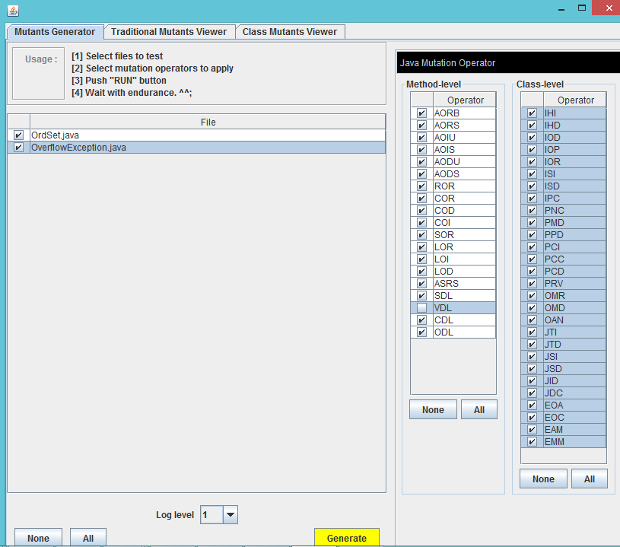

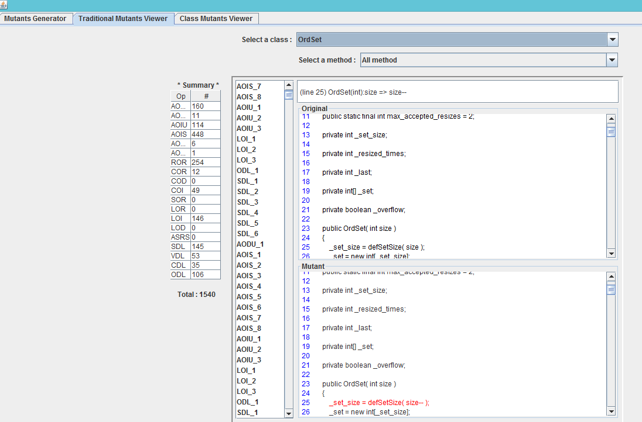

Above Figure shows Traditional Mutants Viewer.

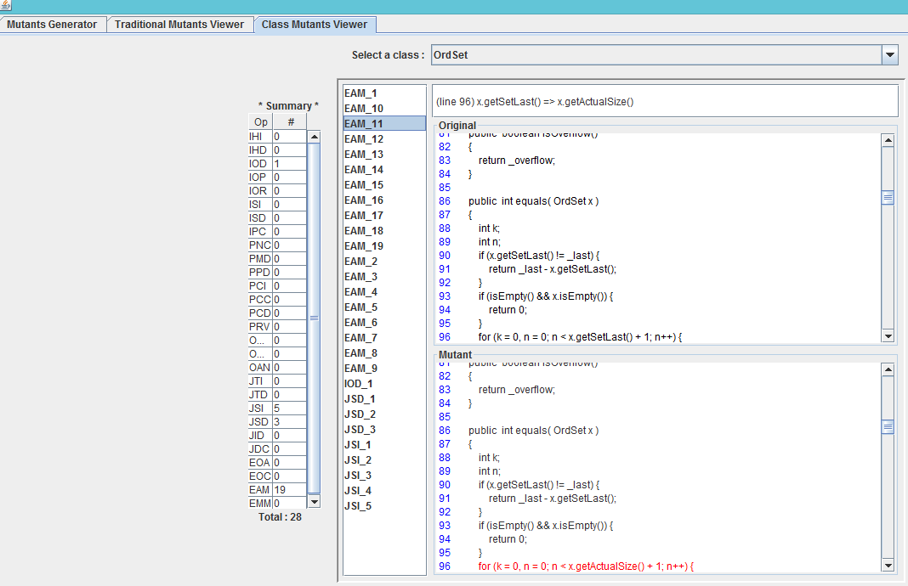

Above Figure shows Class Mutants Viewer.

* Now type below mentioned command:
  + Java mujava.gui.RunTestMain : This will show another gui as below

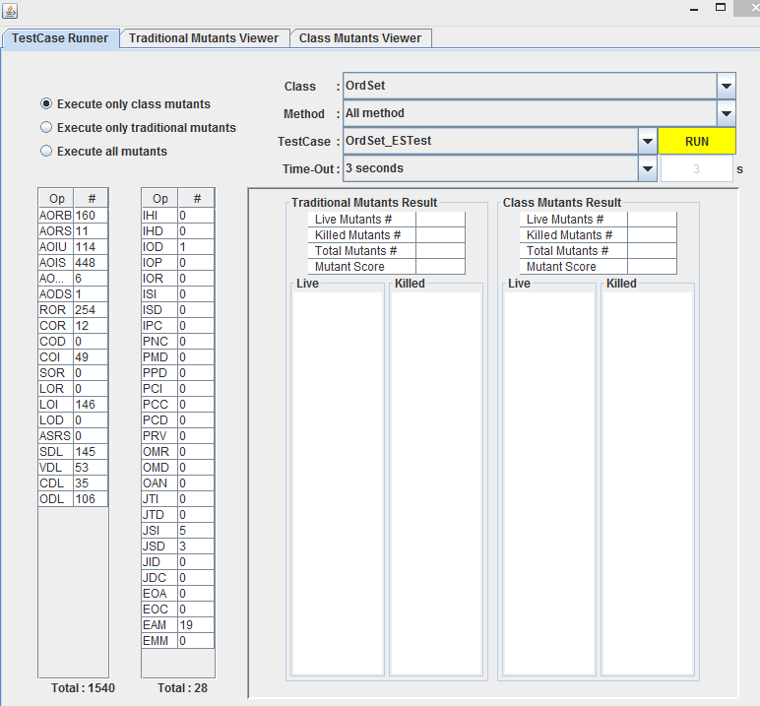

* As we can see there are total 1568 classes that are mutant. So, this will take some time to run.

